MY FOOD DIARY:

Breakfast Break Lunch Dinner

| Monday | Colacao | Pancake | Pasta | Croquetes |
| --- | --- | --- | --- | --- |
| Tuesday | Colacao | Fuet | Paella | Macarroni |
| Wednesday | Yogurt | Fuet | Paella | Pasta |

MY FOOD REPORT

On Monday I had colacao for breakfast. At break I had pancakes. For lunch I had pasta. And for dinner I had croquettes.

On Tuesday I had colacao for breakfast. At break I Had fuet. For lunch I had paella. For dinner I had macaroni.

On Wednesday I had Yogurt for breakfast. For break I had fuet. For lunch I had paella. And for dinner I had pasta.

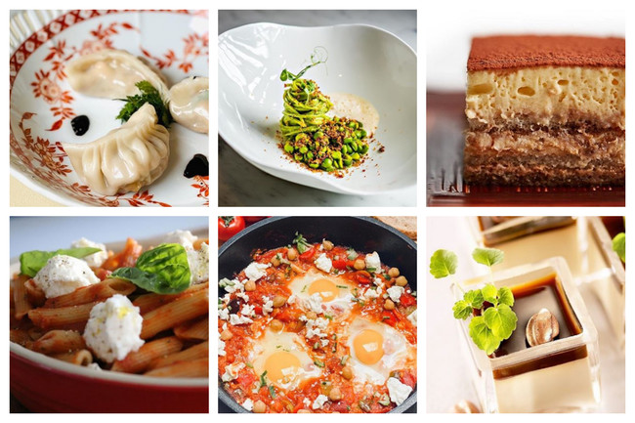

By [Xabier Díaz Latorre](mailto:xdiazlator@educacion.navarra.es)